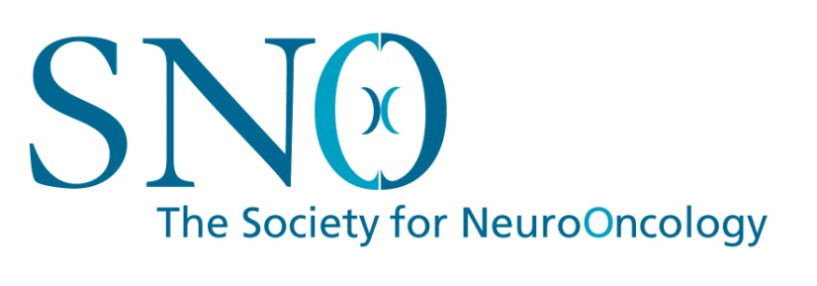

Trainee Registration Confirmation Form

Society for Neuro-Oncology
23rd Annual Scientific Meeting and Education Day
November 15 – 18, 2018
New Orleans, Louisiana

SNO is pleased to offer discounted registration rates to qualifying students and trainees to encourage participation and attendance at the annual meeting. Your assistance is appreciated in verifying that a student under your direction meets the requirements for this special rate by completing the form below.

I confirm that ______________________________________________________________
(name of registrant - please print)

is under my departmental supervision and that he/she is currently a student, resident, or post-doctoral fellow (or other similar position) and does not hold a faculty appointment.

Signature: ________________________________________________________________
Date: ____________________________________________________________________
Print Name: _______________________________________________________________
Title: _____________________________________________________________________
Institution: ________________________________________________________________
e-mail: ___________________________________________________________________
Phone: ___________________________________________________________________

Please return this form to:
Linda Greer, Program Registrar: linda@soc-neuro-onc.org
or fax to 713-583-1345.

